Tenda MW5s-How to check wired connection or wireless connection among nodes in network system?

Step 1: Tap the node you want to check. E.g: Bedroom.

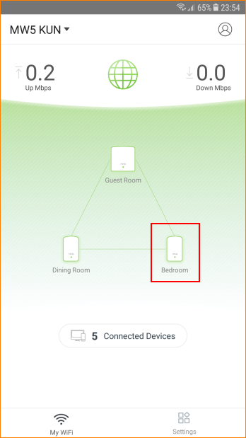

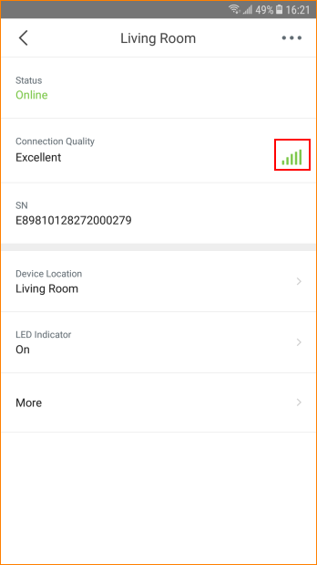

Note: is wireless connection.
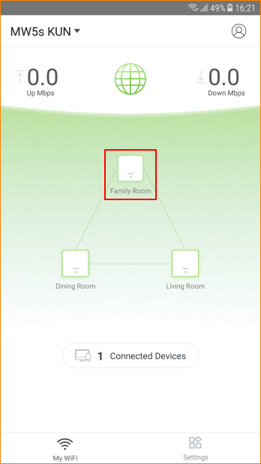

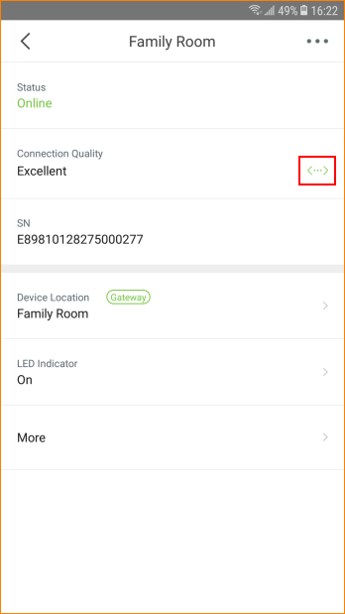

Note:  is wired connection.

